Tableau Coffee Shop Project
For this project, I have used the Superstore dataset since I wasn’t able to access the Coffee Shop one. However, both datasets included similar columns, so I decided that this was the best option.
Task One: Which markets generate the most revenue, profit, and order volume?
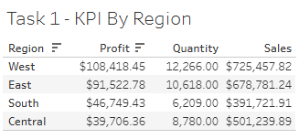
The West region generates the highest sales and profit, indicating strong overall performance. Although the Central region records a high quantity of sales, its profit is comparatively lower, which may suggest higher costs.
Task Two: Which regions are above/below the company average and the sales target?
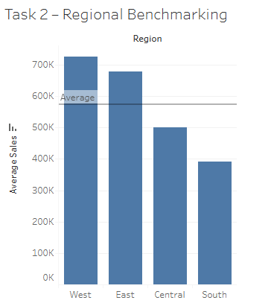
The West and East regions perform above the average sales benchmark, while the Central and South regions fall below it. This highlights an opportunity to improve sales performance in underperforming regions.
Task Three: Which products drive the most profit across the business?
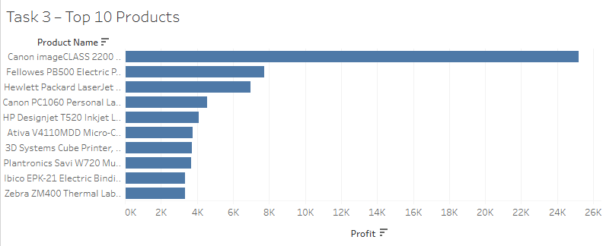
Profit is heavily concentrated among the top 10 products, with these items contributing a significant share of total profit. Focusing on these high-performing products could maximise overall profitability.
Task Four: Is CoffeeChain (Superstore) on a growth or decline trajectory?
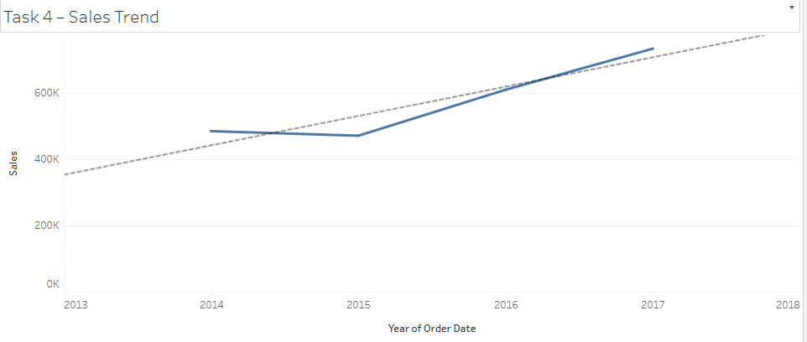
Sales show an overall upward trend over time, indicating consistent growth. Despite the slight decline in sales in 2015, the Superstore shows a positive correlation.
Task Five: What are the expected sales for the next six months, and how confident are we?
Forecasting could not be performed in Tableau Public Web as the feature seems to be available in Desktop only. However, I am aware of how to add this to the chart (under the analytics pane).

